INNOLOFT VENTURES | InnoTrack Daily Report | 20-Day Internship Program

DAILY INTERNSHIP REPORT
Submit this report on InnoTrack by 5:00 PM every day
SECTION 1 — STUDENT INFORMATION

Student Name | R Tarun | VTU ID | 28753
Branch / Dept. | B.tech CSE | Internship Day No. | 4
Date | 04/06/2026 | Track (1 / 2 / 3 / 4) | 1
Project Title | Smart Crop Recommendation Engine - Agriculture | Mentor Name | Jayasri

SECTION 2 — WHAT DID YOU LEARN TODAY?

Topic / Concept Learned (e.g. Random Forest, Flask routing, model saving...)
Matplotlib library
Simple Machine learning

Train/Test Split concept

Build Linear Regression from scratch

SECTION 3 — WHAT DID YOU BUILD TODAY?

Code / Output / Feature Built (e.g. Built EDA section, trained model, created Flask form...)
Charts in One File

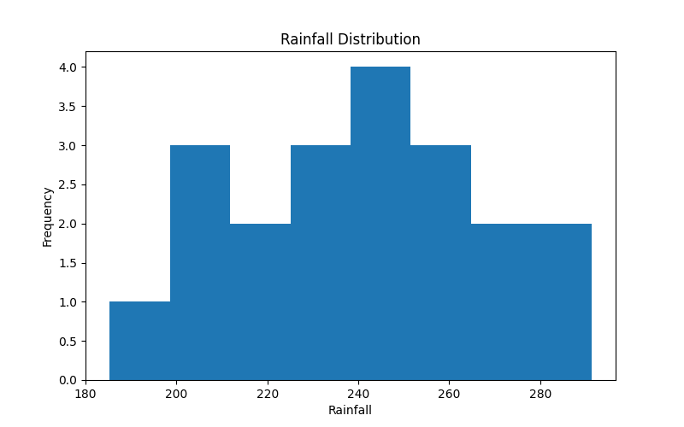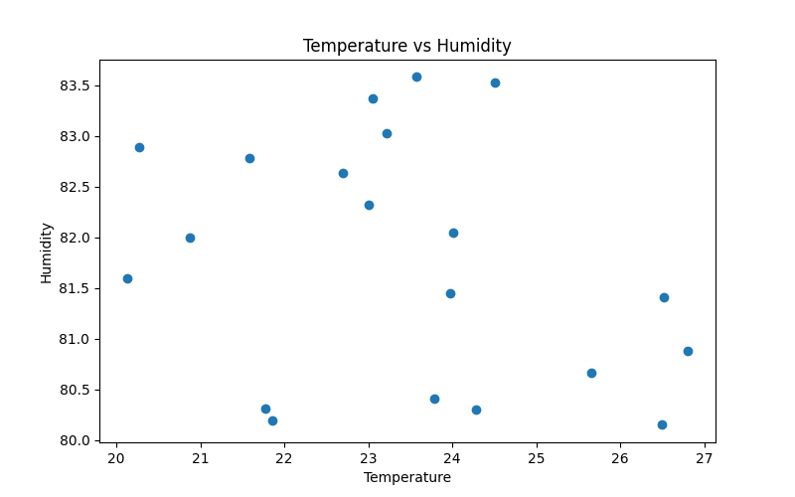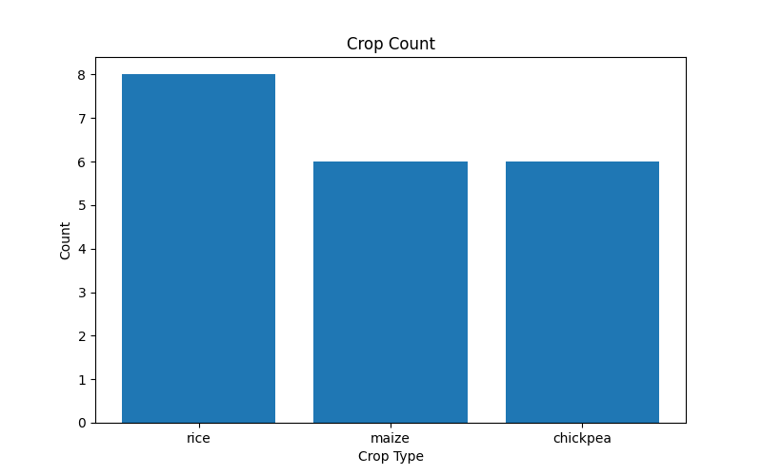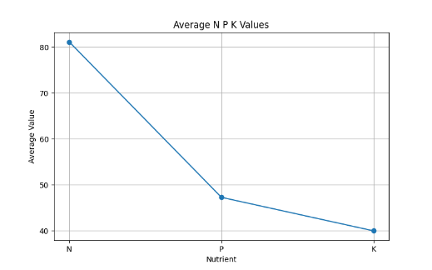
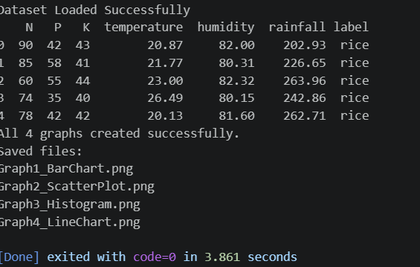
Custom Styled Chart
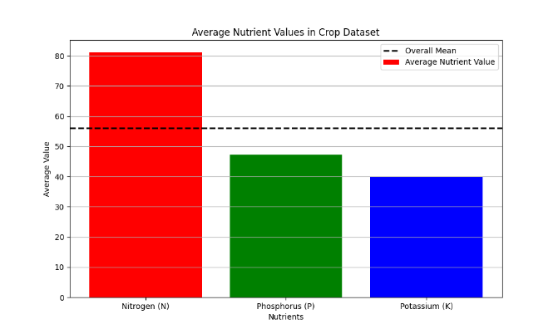
Train-Test Split Explorer
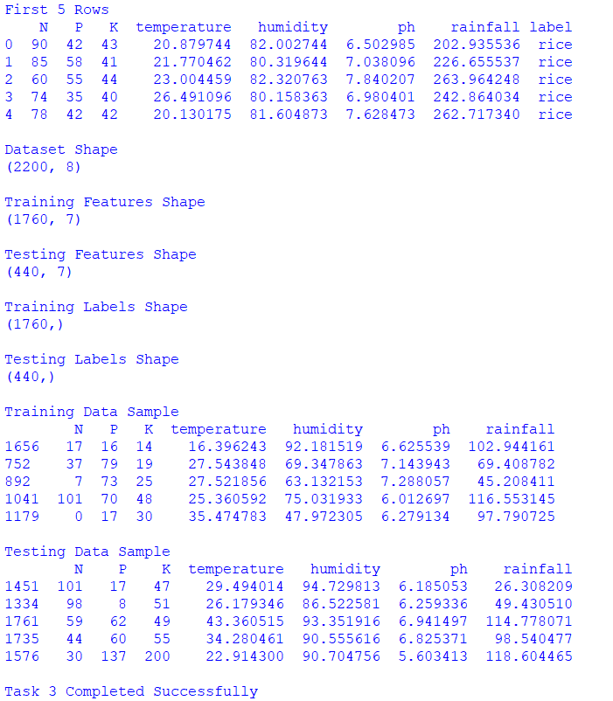
Your First Regression
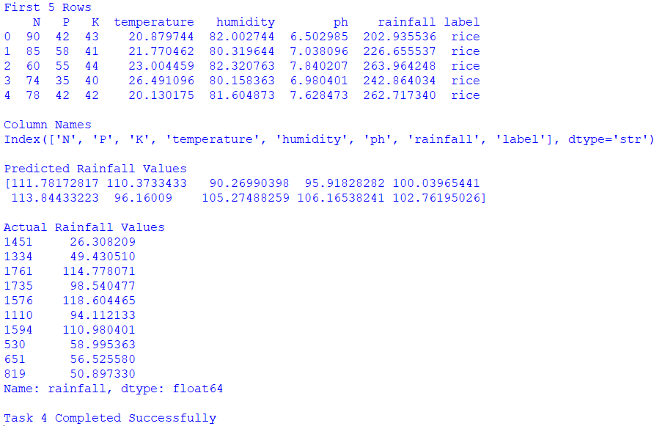

Feature Comparison
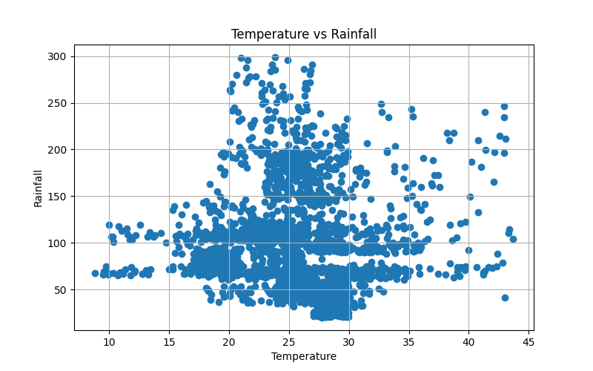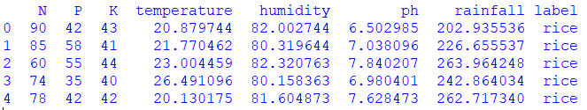
Predict vs Actual Plot
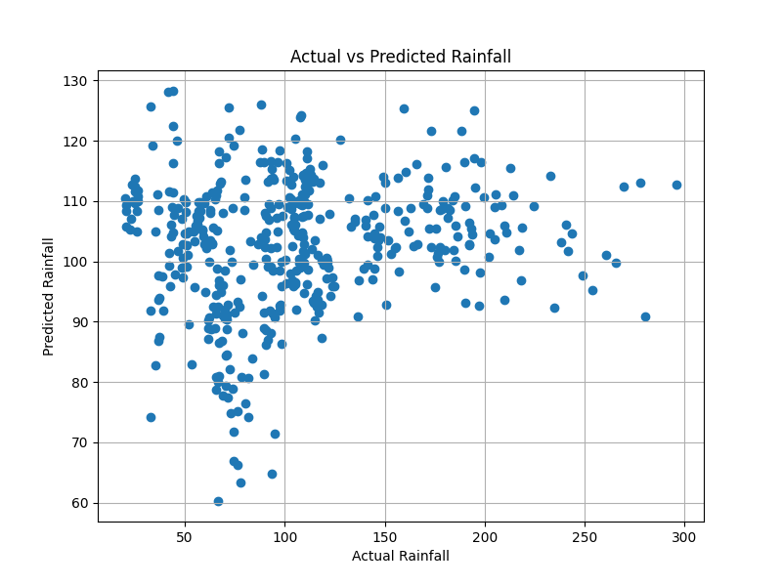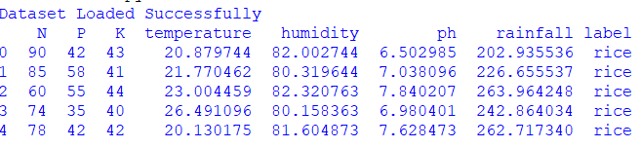
Save Your Model

SECTION 4 — PROBLEMS FACED & HOW YOU SOLVED THEM

Error / Problem (e.g. ValueError when scaling — solved by dropping nulls first)
Graphs were not displaying correctly because only one crop category was present in the sample data, producing limited visualization results.
Errors occurred while reading dataset files due to confusion between ZIP, CSV, and Excel formats during data loading.

How I Fixed I (Describe your solution or what help you took)
Used the complete dataset containing multiple crop categories and modified the plotting code to generate meaningful visualizations.
Extracted the dataset properly, identified the correct file format, and used the appropriate Pandas function to load the data.

SECTION 5 — PLAN FOR TOMORROW

What will you do tomorrow? (e.g. Train Random Forest, compare with Logistic Regression, start Flask app)
Making up the mini project

SECTION 6 — LINKS & ATTACHMENTS

GitHub Repo / Commit Link | https://github.com/rtarun7879-byte/Veltech-Summer-Internship.git
Model Result / Colab Link
Deployed App Link (if any)
Additional Notes

SECTION 7 — SELF RATING FOR TODAY

Area | 1 | 2 | 3 | 4 | 5
Understanding of today's concept | ☐ 1 | ☐ 2 | ☐ 3 | ☐ 4 | ☐ 5
Hands-on coding confidence | ☐ 1 | ☐ 2 | ☐ 3 | ☐ 4 | ☐ 5
Progress on my project | ☐ 1 | ☐ 2 | ☐ 3 | ☐ 4 | ☐ 5
Overall satisfaction with today | ☐ 1 | ☐ 2 | ☐ 3 | ☐ 4 | ☐ 5

